1. **Measurement environments:**

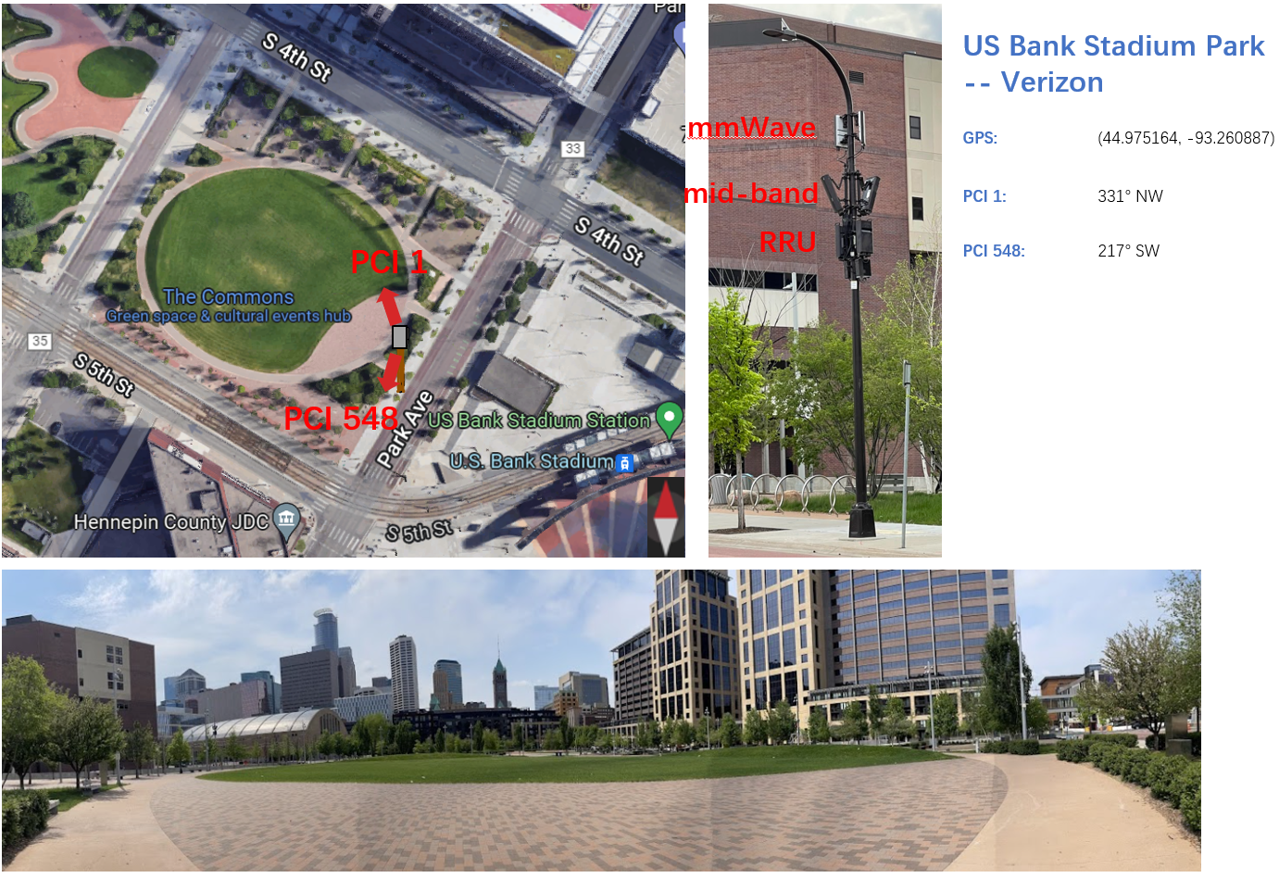

1. **Public Park area**

**We reduce the dataset in GitHub. Feel free to contact** ye000094@umn.edu **for the raw datasets.**

**Several background:**

(1) UE will detect **different PCI’s signal strength** (nbr cell). The measurement tool (XCAL) allows us to access that information at the same time, while Android API is hard to do it.

(2) For mmWave, each PCI has a couple of beams.

(3) Only one PCI_Beam will provide service. And UE will **only get serving cell’s CQI**.

**VZW NR mmWave n261:**

NR-PCI 1 (#samples: 27,630)

|  |  |  |  |  |
| --- | --- | --- | --- | --- |
| PCI 1_4: 11,177 | PCI 1_5: 15,914 | PCI 1_10: 20,583 | PCI 1_11: 4,938 | PCI 1_12: 13,727 |
| PCI 1_13: 17,096 | PCI 1_26: 4,349 | PCI 1_28: 4,729 | PCI 1_29: 5,648 |  |

NR-PCI 548 (#samples: 16,161)

PCI_SSB ……

NR-PCI 377 (#samples: 16,556)

PCI_SSB ……

NR-PCI 255 (#samples: 24,836)

PCI_SSB ……

**VZW LTE Mid-band B66:**

LTE-PCI 128 (#samples: 14,483)

LTE-PCI 162 (#samples: 10,428)

LTE-PCI 202 (#samples: 9,868)

LTE-PCI 224 (#samples: 19,745)

LTE-PCI 288 (#samples: 24,887)

**VZW LTE Low-band B13:**

LTE-PCI 288 (#samples: 31,894)

1. **UMN area**

**We haven’t public this dataset so far. Please contact** ye000094@umn.edu **if you are also interested in it.**

**TMB NR Mid-band n41:**

NR-PCI 319

NR-PCI 829

NR-PCI 177

NR-PCI 553

**TMB LTE Mid-band B2:**

LTE-PCI 95

LTE-PCI 108

LTE-PCI 457

LTE-PCI 489

**TMB LTE Mid-band B66:**

LTE-PCI 135

LTE-PCI 188

LTE-PCI 260

LTE-PCI 433